MIDDLESEX COUNTY ACADEMY

SENIOR PROJECT
DESIGN REQUIREMENTS & SPECIFICATIONS
DOCUMENT

PROJECT NAME: ___________________________________

REVISION: __________________

DATE: ___________________

Author 1: ________________ INSTRUCTOR: Mr. E. PATERNO

Author 2: _________________

Author 3: __________________

TABLE OF CONTENTS

1 TERMINOLOGY 4
2 DOCUMENT HISTORY 4
3 PROJECT OVERVIEW 4
4 PROBLEMS ADDRESSED 4
5 APPLICATIONS 4
5.1 Immediate Applications 4
5.2 Future Applications 4
6 PATENT SEARCH RESULT 4
7 HIGH LEVEL BLOCK DIAGRAM 5
7.1 Diagram Functional Descriptions 5
8 DELIVERABLES 5
9 TASKS & RESPONSIBILITIES 6
10 GANTT CHART 6
11 RISK FACTORS & CONTINGENCY PLANS 7
12 DESIGN CONSTRAINTS 7
13 FEATURE REQUIREMENTS 7
14 USER INTERFACE REQUIREMENTS 7
15 HARDWARE SPECIFICATIONS REQUIREMENTS 8
15.1 Microcontroller Requirements 8
15.2 Memory Map Specification 8
15.3 I/O Specification 8
15.4 Timing Considerations 8
15.5 Calculations 8
15.5.1 Power Calculations 8
15.6 Simulations 8
15.7 Bill of Material (BOM) 9
16 FIRMWARE REQUIREMENTS 9
16.1 Program Language Specification 9
16.2 Code Size Specification 9
16.3 I/O Interface specification 9
16.4 Timers Specification 9
16.5 ISR Specification 9
16.6 Pseudo-code listing 9
16.7 Flow Chart /pseudocode 9
17 MECHANICAL REQUIREMENTS 9
17.1 Housing Mechanical Drawings 9
17.2 Board layout 9
17.3 Mounting Apparatus 9
18 CONCURRENT ENGINEERING REQUIREMENTS 10
19 COST ANALYSIS 10
20 RESOURCE REQUIREMENT 10
21 UNIT TEST SPECIFICATIONS 10
22 INTEGRATION TEST SPECIFICATIONS 10
23 SYSTEM TEST SPECIFICATIONS 10
24 PRODUCT LIMITATIONS 10
25 OPEN ISSUES 11
26 FUTURE IMPROVEMENTS 11
27 REFERENCES/ACKNOWLEDGEMENTS 11

TERMINOLOGY

This section provides a definition for the technical terminology used in this document. As well, this section provides the definition for the various acronyms in alphabetical order.

Example:

AM – Amplitude Modulation
PCM – Pulse Code Modulation
DIVA – Digital Input Voice Activation

DOCUMENT HISTORY

This section provides a brief description of the changes that occurred for each version of the document.

Example:

10/29/03: Draft - Initial Draft version of the document
11/29/03: Version 1.0 - Modification of the block diagram so to show the exact microcontroller used in this project. Refine the product requirement section.

PROJECT OVERVIEW

Describe the project overview. Describe, at a high level, what are the key points of this product. Basically, a reader should feel fairly comfortable to as exactly what this project is, without a detailed description of the design.

PROBLEMS ADDRESSED

Describe problems addressed with this product – the idea. List existing similar products and how this design alleviates the existing problems.

APPLICATIONS

Describe the current proposed application of the product. As well, list potential future applications that can be realized with this design if given more time and budget.

Immediate Applications

Future Applications

PATENT SEARCH RESULT

This section needs to discuss one or more patented products that are very closely related to this project. Provide patent search results and provide a comparison of the different products. Specifically, describe the main advantages of the new product over any existing similar products. Remember that if one is to make the search too specific, no patents will be found. One needs to broaden the search for any product that have similarities and most probably have a different implementation. Many products are patented for a particular idea and this idea is realized through a particular implementation.

The patent search website is: http://www.uspto.gov or www.google.com (click on more/patents)

HIGH LEVEL BLOCK DIAGRAM

Show a high level functional block diagram of the product. This is NOT a flowchart. This diagram is the second phase of your design (i.e. phase 1 → idea). Following the TOP DOWN design principle, this block diagram presents a very high level overview of the design from a block diagram point of view. Each block represents a major function and is labeled as such. Arrow between blocks shows the flow of the data in/out of the blocks. These could be a single signal or a bus. If this product is part of an existing product, differentiate between the new blocks and the existing blocks.

Example:

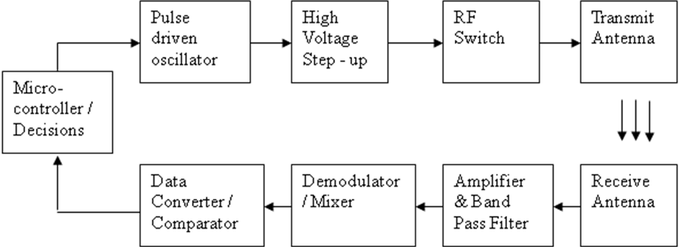

Diagram Functional Descriptions

Give a functional description for each block. The description must include the major components that make these functionalities possible. Also describe the interfaces between each block (Is it a hardware interface, Software interface or both?).

DELIVERABLES

The senior project requires the project team to provide one major deliverable per marking period. A deliverable is defined as a working subsystem of the overall design (i.e. system). Thus, a task at hand is to partition the design into four subsystems and each one becomes a deliverable. The deliverable is to be demonstrated to the entire class. A deliverable can be hardware only, software only, or a combination of both. As such, each deliverable is named a sub-system.
The table below shows the means of presenting the four deliverables:

Subsystem I

MP1

Subsystem II

MP2

Subsystem III

MP3

Subsystem IV

MP4
A name for each subsystem is to be provided. As well, give a brief explanation of the functionality for each subsystem.
MP1: For this marking period:
- Block diagram is finalized
- Hardware Schematic is provided (Show All parts, Reference designations, Values of components, part numbers, Signal names, Pin numbers)
- Firmware state diagram or flowchart

TASKS & RESPONSIBILITIES

List the various responsibilities required to realize this design. As well, show the breakdown of these responsibilities amongst the team members. Any tasks that are time consuming should be described here as they take away from the allowed schedule

GANTT CHART

Attach the Excel chart used to generate the Gantt chart. – show ALL the tasks necessary to realize the project. Along with each task is associated the responsible team member for that task and the duration of time required to conclude this task. The Gantt chart also needs to show the several milestones defined by the team members as well as the four deliverables described earlier. The deliverables are milestones BUT a milestone is not necessarily a valid deliverable. A deliverable needs to satisfy the criteria described in the earlier section.

A suggested FREE software package that allows Gantt chart generation is:

OpenWorkbench: http://openworkbench.org

Example:

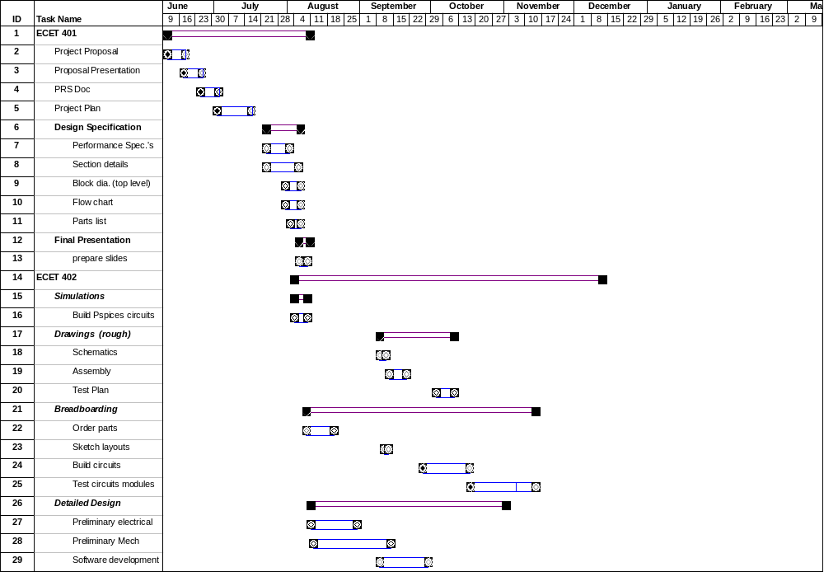

RISK FACTORS & CONTINGENCY PLANS

List all the known risks associated with this project. A risk is defined as a particular concern that might prevent the design to be completed successfully. An example of a risk is the lead time for a particular component. A non-working source code is not an example of a risk factor, but, an example of a design failure. For each risk factor, list a contingency plan.

DESIGN CONSTRAINTS

List all the known design constraints. A design constraint is defined as a known situation (i.e. a design limitation) that affects the functionality of the product under certain conditions (i.e. environment). The team is aware of his issue and is willing to allow this design constraint to be part of the final product.

FEATURE REQUIREMENTS

List ALL feature requirements that are committed when delivering this product.

USER INTERFACE REQUIREMENTS

List ALL User Interface requirements that are committed when delivering this product.

HARDWARE SPECIFICATIONS REQUIREMENTS

This section lists ALL Hardware specifications needed to perform the hardware design.
The specifications are described in great detail.
The Hardware Specifications section includes the following items.

Microcontroller Requirements
Describe, at an high level, the major requirements that impact the selection of the proper microcontroller. For example these might include:

- Availability
- Cost
- SMT Vs Through-hole
- Learning curve
- Support
- Lead time
- Memory requirements (Flash, SRAM, Stack, EEPROM)
- I/O requirements
- Embedded features (i.e. ADC, PWM, timers, Interrupts, Input Capture/Output Compare, Parallel Ports, RS-232 - UART, etc…..)

Each sub-section below emphasizes details about the requirements mentioned above.

Memory Map Specification
Show the memory map diagram of any memory devices used in the design – If applicable

I/O Specification
This section describes the required I/O needed to implement this design

Timing Considerations
This section describes any timing considerations for hardware design modules that interact with each other. Calculations relating to timing specifications (i.e. Clocks, propagation delays, etc…) are presented here – If applicable

Calculations
This section details any and all calculations performed to define design implementations

Power Calculations
This section details the power calculations showing the power consumption of this product

Simulations
These section details simulations performed to demonstrate validity of certain design criteria

Bill of Material (BOM)
This section details all the parts needed to implement this design. All parts listed here are also shown on the schematic and each part must have a reference number (i.e. R1, IC1, C1, etc…..).
This information is shown in a tabular form, (i.e. Excel), with the following information:

Item Number
Part Number
Reference Designation
Manufacturer
Second Source
Part Description
Lead Time
Part Availability (i.e. On-Hand)

FIRMWARE REQUIREMENTS

This section lists ALL Firmware specifications needed to perform the firmware design.
The specifications are described in great detail.
The Firmware Specification section includes the following items.

Program Language Specification

Code Size Specification

I/O Interface specification

Timers Specification

ISR Specification

Pseudo-code listing

Flow Chart /pseudocode

MECHANICAL REQUIREMENTS

List ALL Mechanical (i.e. housing, casing, and physical) Specifications needed to implement this design.

Housing Mechanical Drawings

Board layout

Mounting Apparatus

CONCURRENT ENGINEERING REQUIREMENTS

List ALL Concurrent Engineering requirements that are committed when delivering this product.

COST ANALYSIS

List ALL Costs required to realize this product

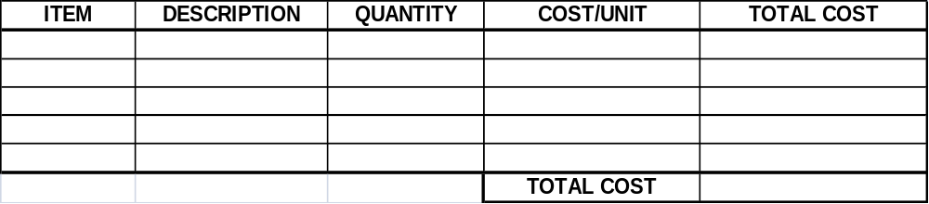

RESOURCE REQUIREMENT

List all the resources required for completing this project successfully. Such resources include equipment, software packages, instruments, and particular technologies. Do not list the obvious.

UNIT TEST SPECIFICATIONS

List all Unit Test cases required to test each function block. The testing needs to be complete such that performing these test cases successfully guarantees a 100% working function block.
Each Unit Test Case must be detailed enough so that anyone not familiar with this product can perform the unit test case (list all equipment needed to perform the test and the procedures).

INTEGRATION TEST SPECIFICATIONS

Integration testing is used for testing the operation that results when cascading blocks. Integration testing is also used when testing hardware together with its controlling firmware.
Basically, whenever blocks are joined together to form a new block, the resulting testing is now called integration test as it is not a unit test per say because it is testing the cascading of units.

SYSTEM TEST SPECIFICATIONS

System test is the test of the entire product under various operating conditions.
This test needs to cover all the cases that this product might be subjected to. Basically, think of these tests as the final tests that would be performed on a product before being shipped to a customer. Thus, the test cases are designed to emulate all the possible of the product by either knowledgeable customers or customers who are not too keen in using technology.

PRODUCT LIMITATIONS

List any known product limitation. Describe when will they be resolved if ever.

OPEN ISSUES

List all the known open issues. An open issue is a known design issue that needs to be resolved prior to the completion of the product. If this issue is not resolved, a design constraint is created or a non-working product is created.

FUTURE IMPROVEMENTS

List any upgrades to this product that will be made in the future. These upgrades are features not supported in the delivered product but can be provided at a future time given extra time and money.

REFERENCES/ACKNOWLEDGEMENTS

Provide acknowledgements to individuals that have been contributors to the success of this product and are not officially team members.
List all references. For websites, show the URL. For books, show the title, author and publisher. For magazines, show the title and volume number.

